Testing the 50 V Power Supply Unit

Servicing a SuperDARN Transceiver  
Step 2

Content

1. Introduction 3

2. Instructions 3

3. Conclusion 3

# Introduction

This document provides work instructions for testing the 50 V Power Supply Unit in a SuperDARN transceiver box. Before attempting to implement these instructions, be sure to complete all the preceding steps in the procedure for Servicing a SuperDARN Transceiver.

# Instructions

*Figure 1* illustrates the important connections and locations necessary to complete the instructions listed below.

1. The C13 mains connector on the back of the box requires a 3.15A slow blow fuse. Confirm that the fuse is present and intact.
2. Connect the AC mains power cord to the 50 V Power Supply Unit and switch it on.
3. Use a DMM to measure the output voltage of the PSU and confirm that it is 50±0.5 V.
4. If the voltage is out of range, use a small screwdriver to adjust the small potentiometer (Vadj) on the back of the PSU itself.
5. Power Down.

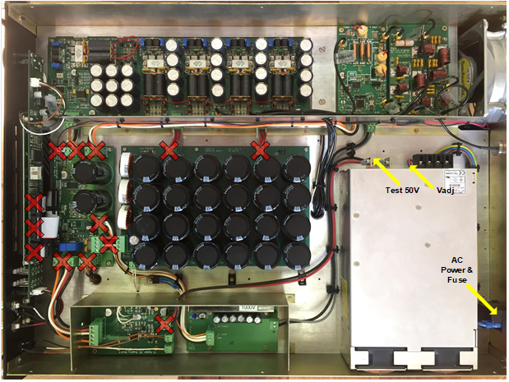

Figure . Transceiver box connections for testing of 50 V PSU.

# Conclusion

This concludes the work instructions for testing the 50 V Power Supply Unit of a SuperDARN transceiver box. The next step in the procedure for Servicing a SuperDARN Transceiver is to test the DC Supply Board.